To Move Changesets(files) to another CR in Rational Clearquest

1. Checkout a file in your snapshot view and create a new ChangeRequest(CR).

2. Then Undo the checkout of this file. (You just want the new CR attached to this stream.)

3. call up the CR in Clearquest that you want to move the files from.

4. Select appropriate Changesets(files) from the Change Request.

5. Highlight changesets and right click and select 'Move to Activity'

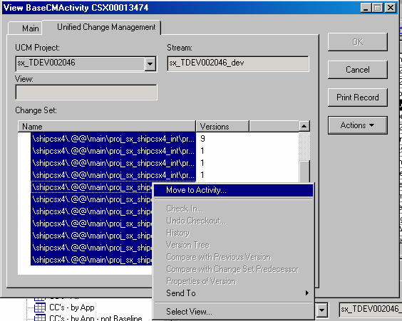

6. Click check box for show all users' activities then select by the Change Request Description and select OK.

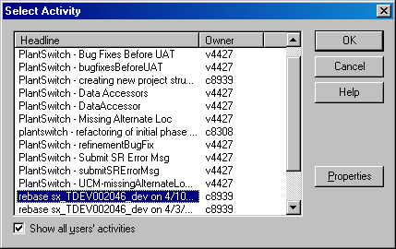

7. Click "OK" and the files are moved to the new CR and you can edit or build the files on the new CR as needed.

